CSA1708-ARTIFICIAL INTELLIGENCE
LAB EXPERIMENTS
Program 14 : Python Program to Implement Alpha & Beta Pruning Algorithm for Gaming
Aim
To develop a Python program to implement the Alpha-Beta Pruning algorithm to optimize the Minimax search by pruning redundant branches in a game tree.
Algorithm
1. Represent the adversarial game as a game tree with terminal leaf node values.
2. Initialize search parameters: alpha = -infinity (best maximizer value) and beta = +infinity (best minimizer value).
3. Define the recursive function taking depth, node index, player flag (is_max), terminal scores, alpha, beta, and tree depth.
4. If current depth equals maximum tree depth, return the leaf utility value.
5. If the current turn is for the Maximizing player:
6. a. Set best_score = -infinity.
7. b. For each child branch of the current node:
8. i. Evaluate child value recursively with is_max = False.
9. ii. Update best_score = max(best_score, child_val).
10. iii. Update alpha = max(alpha, best_score).
11. iv. If beta <= alpha, prune remaining sibling branches (cutoff condition) and break loop.
12. c. Return best_score.
13. If the current turn is for the Minimizing player:
14. a. Set best_score = +infinity.
15. b. For each child branch of the current node:
16. i. Evaluate child value recursively with is_max = True.
17. ii. Update best_score = min(best_score, child_val).
18. iii. Update beta = min(beta, best_score).
19. iv. If beta <= alpha, prune remaining sibling branches (cutoff condition) and break loop.
20. c. Return best_score.
21. Execute search from root node and display optimal minimax game value achieved with alpha-beta pruning.

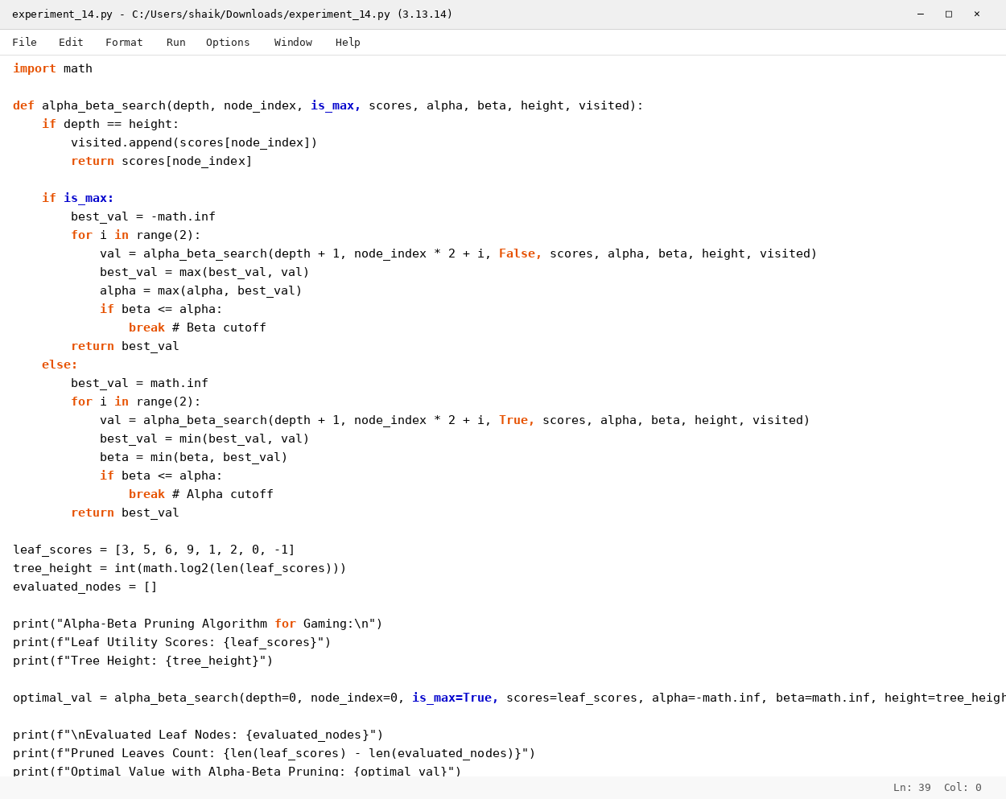

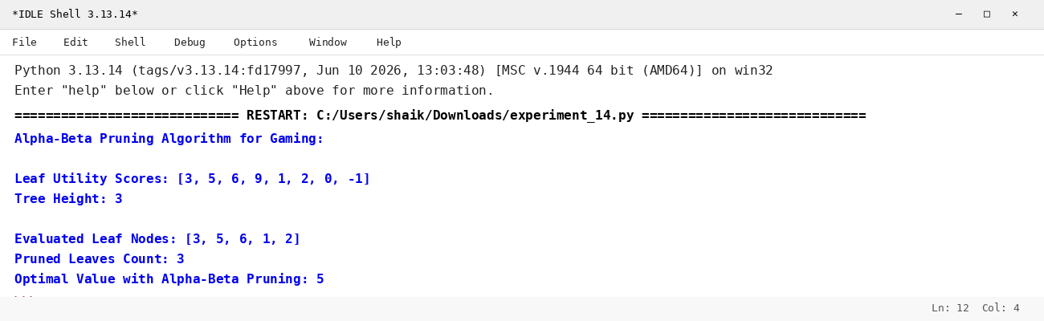

RESULT
Thus, the Alpha & Beta pruning algorithm for gaming was implemented successfully using Python.

